Operation Instruction for the Software
Note: Please install the program before run the RS232 software.
- Run the program, click “Extract”.
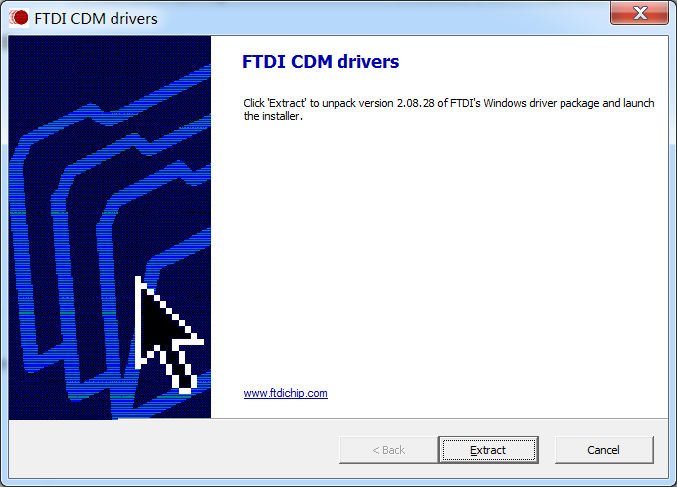

- Click”下一步”as shown.
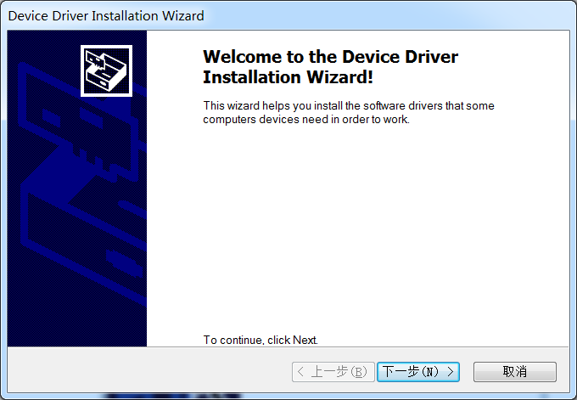

3. Click”完成”.
